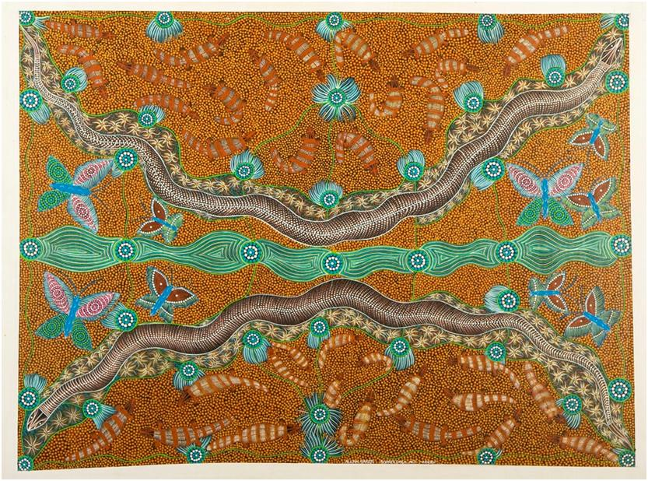

PROJECT FUNDING GUIDELINES

OBJECTIVES AND FOCUS AREAS

The McArthur River Mine Community Benefits Trust was formed in 2007 under an agreement between McArthur River Mining (MRM) and the Northern Territory Government to support the social and economic development of the Northern Territory Gulf region.

It is a charitable Trust which aims to:

- Facilitate ongoing sustainable development of the community and the region including community capacity building and local business enterprise development

- Build infrastructure within the community to a level that will facilitate the creation of local jobs, diversity of new enterprise, beneficial social activity and improved health outcomes

- Enhance the positive social and economic impact of MRM’s mining operations on the community and the region as far as is reasonably practical

- Create jobs and training opportunities.

The charitable purpose of the Trust is to provide:

- Grants, scholarships, bursaries and other assistance for education, vocational training and enterprise development

- Grants and other assistance for community infrastructure, and community development including the promotion of initiatives in the areas of health, law, arts, sport and culture.

The Trust is committed to supporting:

- Employment, training and enterprise development generated both through MRM’s mining operations and in the wider Borroloola economy including:
- Fulfilling MRM’s target to achieve 20% workforce participation by Indigenous people
- The commitment to generate and support the establishment of one new local business per annum to supply a product or service to the mine

- Community-based package of social and economic programs benefiting: enterprise and job creation; environment; education; social and community development; health; culture and art.

The Trust is, in practice, a partnership between the Government, MRM and the community in promoting the socio-economic development of the region. There are various opportunities for the community to be engaged through consultation.

Importantly, 10 of the 14 Directors on the Trust Board are representatives of the community – one from each of the four local Indigenous language groups – Yanyuwa, Garrwa, Gudanji and Marra – and two elected by the community. Their role as Directors provides a local voice in decision-making and helps ensure community needs are targeted.

Region Serviced

The Trust supports the Gulf region which comprises the communities bounded by Robinson River in the south-east, Sir Edward Pellew Islands in the north, Limmen Bight River in the west and Balbirini Station in the south. The township of Borroloola sits at the heart.

Community Vision, Needs and Priorities

Through consultation and engagement programs, members of the Gulf regional community have expressed a vision to create a vibrant, thriving and healthy region.

In order to support the achievement of this vision, the Trust funds programs in the following six categories through both the grants program and CBT-led projects. A description of the identified needs within each of these categories as identified through community development planning is also provided through the Three Year Plan and Annual Priorities.

- Enterprise and job creation: Supporting programs that promote employment and local business establishment and development to create a diverse local economy and sustainable job opportunities.

- Education: Improving literacy, numeracy and commitment to learning from pre-school through to tertiary levels and to support greater pathways between vocational educational training and local employment and business opportunities.

- Social and community development: Promoting a higher standard of living by addressing issues such as overcrowding in local homes and welfare dependency and by providing services and facilities to foster a positive sense of community and town pride.

- Environment: Supporting the sustainable development of industries such as eco-tourism and fishing, and the protection and preservation of Indigenous country of cultural significance.

- Health: Improving the health and well-being of the community including action to address drug and alcohol abuse, chronic diseases and provide access to affordable, healthy food.

- Culture and Art: Supporting the sustainable growth of existing art and culture organisations in a way that promotes generational understanding of Indigenous culture and traditions and the establishment of sustainable culture-based businesses with tourism objectives.

Each year, the community is engaged with to identify specific priorities in line with the needs expressed. These priorities are considered by the Trust Board in developing the Annual Priorities in targeting specific programs for support. These Annual Priorities support the Three Year Plan.

WHO CAN APPLY

The Trust invites applications for grant funding from organisations interested in undertaking projects or programs which align with and support the achievement of the Trust’s objectives and the community’s specific needs. To be eligible, the project must be of benefit to the community of the Gulf region.

A project is eligible for support by the Trust if it:

- Is conducted for a charitable purpose, that is:
  - providing grants, scholarships, bursaries and other assistance for education, vocational training and enterprise development; or
  - providing grants and other assistance for community infrastructure, and community development including the promotion of initiatives in the areas of health, law, arts, sport and culture.

- Is not an excluded project i.e.:
  - not for a charitable purpose
  - is for funding funerals
  - is an ex gratia payment to an individual or individuals.

- Has the support of relevant local community organisations:
  - Local Aboriginal Elders (for Aboriginal culture, arts and/or storytelling projects)
  - School Council (for education, sport and young people’s programs)

- Has the appropriate legal framework in place, i.e.:
  - land tenure / ownership / security (for projects involving building and development); or
  - owner’s consent (for projects involving land not owned by the Applicant); and/or
  - legal use (for projects requiring approvals e.g. Section 19)

- Is consistent with the Trust’s Three Year Plan and Annual Priorities as developed by the Trust Board and following community consultation.

All applications will be considered, however preference will be given to applications which:

- Address the expressed priorities of the community to resolve major issues impacting on the sustainability of the region and in so doing, make a real difference

- Help build local capacity in a long-term, sustainable manner

- Are catalysts for greater investment in the community either through additional external funding opportunities (other than the Trust), revenue-generation or other self-sustaining methods.

- Meet the legal eligibility criteria and Board requirements

Generally, projects will not be considered for funding when, in the opinion of the Trust Board, they are the operational responsibility of Federal, Northern Territory or Local government.

SUPPORT PERIOD

Grants to approved projects can be offered for up to 3 years subject to regular performance reviews. Long term projects beyond 3 years in duration will require a new submission to be lodged and assessed for any subsequent terms. Reporting requirements will be detailed in specific Funding Agreements.

GRANTS FOR CULTURAL PROJECTS

Applications for grant funding that is concerned with local cultural knowledge including Aboriginal culture, arts and/or storytelling projects should be presented with a letter of support from local Elders and community member representing the clan groups. This can be done through the Mawurli and Wirriwangkuma Aboriginal Corporation (MAWA), representing each of the four local Indigenous language groups in the Gulf Region around Borroloola. The contact details for MAWA are below:

Mawurli and Wirriwangkuma Aboriginal Corporation (MAWA)
m: 0456 600 566
e. coordinator@mawagroup.com.au

GRANTS FOR YOUTH PROJECTS

Applications for grant funding that is concerned with young people in the community should be presented with a letter of support from the Borroloola School Council.

Borroloola School Council
ph: 08 8965 1801
ph: 08 8975 8780

REPORTING

In general terms, reports required to be provided by grant recipients should cover the following content as relevant for the projects supported. A hypothetical example is provided in the interests of clarity.

Content | Definition | Example
Inputs | Resources you put into a project whether in terms of money, in-kind support or infrastructure. | - Total cost of an education project.  - Number of teachers provided.
Outputs | These are the immediate products, services or deliverables that the project generates or provides as a result of the inputs. | - The number of children participating in the program.  - Number of books shared.  - Number of visits conducted.
Outcomes | Results that constitute the desired return on the investment in the project, for example, changes in the community’s quality of life, health standards or job opportunities. | - Impact on attendance rates at the school.  - Impact on literacy.

A description of these targeted results for each project supported by the Trust will be captured within the Key Performance Indicators and acquittal schedule described within the Funding Agreements. Progress reports will be assessed by the Trust Project Officer and releases of further funding will be dependent on the satisfactory progress of the project.

All grant recipients will be required to provide written reports of results as per the Funding Agreement milestones. At the completion of the project, a final report along with an acquittal of funding will be required within 4 weeks of the conclusion.

Further reporting may be required which will be determined and agreed through consultation with the Project Officer.

Annual Review Reporting Requirements
Additional to meeting Funding Agreement requirements, project reporting will be used for the preparation of an Annual Review of Trust activity. This report is posted online at CBT website and distributed to relevant stakeholders, including the Northern Territory Government and McArthur River Mine.

Photographs of your project in action would be appreciated with these reports. The intention would be to use these photographs within the Annual Review promotional activities.
Note: Use of personal images must be authorised. Please confirm that approval is given to reproduce the photographs provided.

HOW TO APPLY

Stage One - Expression of Interest

Expressions of Interest (EOI) may be made in writing with completed forms being submitted by email.

The EOI Form is available in Microsoft Word format either directly through this site or via contact with the Project Officer (see contact details at the end of this document)

Submit EOI
Expressions of Interest should be submitted by email to the following address. For further information, please contact the Trust Project Officers at the email or number below.

Email: cbt@planc.com.au
Enquiries: Jim Gleeson 0422 794 072

Assessment of EOIs
The procedure for assessing Expressions of Interest is as follows:

- EOI is received by the Project Officer who will provide notification (email) confirming receipt of the EOI

- Initial assessment is made by the Project Officer to ensure that the EOI has been completed satisfactorily, requesting additional information is required.

- EOI presented to the Board at the quarterly board meeting

- The Board approves a Stage Two – Full Application for the project

- The Project Officer contacts the Organisation to inform them of their success in proceeding to Stage Two - Application, providing them with an Application Form and advice where needed

Stage Two - Application

Applications may only be made in writing with completed applications being submitted by email.

The Project Funding Application Form is available in Microsoft Word format either directly through the website or via contact with the Project Officers (see contact details at the end of this document).

Applications should be succinct and:

- Identify specific objectives or problems and present specific plans and solutions

- Show that the project is planned around an achievable timetable and budget

- Be able to demonstrate that the project is directed at solving problems in a sustainable way rather than providing short-term relief from symptoms or long-term dependency

- Build in reporting and evaluation of the project

- Be innovative and present a project idea that may not readily attract funding from traditional sources.

- Involve a co-contribution of funding from the organisation and other funding sources

Fill in the Project Funding Application Form
Please answer each question and submit copies of relevant documentation with the application form. You may provide additional information to support your submission if you wish to.

In regard to the section on Financial Management (section 8 of the form), please note that grant funding is committed exclusive of GST.

Grant recipients that are registered, required to be registered, or become registered for Goods and Services Tax (GST) will be required to provide valid tax invoices prior to any funding payments being made where the funding payment needs to be grossed up for GST.

Recipients should assess whether they will be liable for GST on receipt of the grant and must notify the Trust’s Project Officers where GST is applicable. The Australian Business Number (ABN) of a grant recipient should also be included in a submitted funding application form.

Submit application
The Project Funding Application Form and supporting documentation should be submitted via email to:

Project Officer
Email: cbt@planc.com.au

When to apply
Applications can be made each quarter for the quarterly board meeting. Applications should reach the Project Officers two weeks in advance of the board meeting to be considered at the meeting (generally occurring in the third week of the month). Dates will be advised on the CBT Facebook page. Please contact the Project Officers if further assistance is required.
The Trust’s Allocation and Investment Committee meets to assess applications at least four times a year. Applications should reach the Project Officer by the following dates to be considered in the appropriate meeting cycle for a timely response:

Assessment of Applications
The procedure for assessing applications is as follows:

- Application is received by the Project Officer

- Application will be recorded and written notification (email) sent confirming receipt of the application.

- Initial assessment is made by the Project Officer to ensure that the application has been completed satisfactorily, meets the guidelines and is accompanied by the appropriate documentation. Further information may be sought from the organisation making the submission.

- Applications and recommendations are forwarded by the Project Officer to the Trust Board in relation to applications to be funded.

- The Trust Board will discuss the proposed projects, review all recommendations from the Project Officer and make final decisions in relation to applications to be funded.

- Applicants will receive a response within approximately three weeks of the board meeting.

- Successful applicants will be required to enter a Funding Agreement with the Trust which agrees to the commitment of grant funding in return for the delivery of the approved project and a defined set of Key Performance Indicators.

MORE INFORMATION

For more information on the McArthur River Mine Community Benefits Trust please contact the Project Officers who are appointed by MRM:

Plan C
Jim Gleeson: 0422 794 072
Email: cbt@planc.com.au

